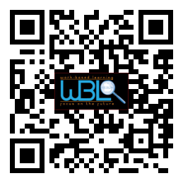

## AGENDA

# WBL/YAP Advisory Committee

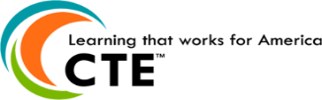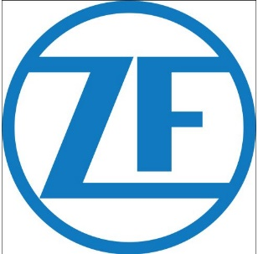

*Thank you ZF for awarding Hall County WBL with the ZF Gives Grant*

**Hall County Career Specialist**

Holli Howard, Chestatee High

Staci Crain, East Hall High

Christy Carter, Flowery Branch High

Karen Filchak, Flowery Branch High

Cree Aiken, Johnson High

Deana Harper, North Hall High

Suzanne Haynes, West Hall High

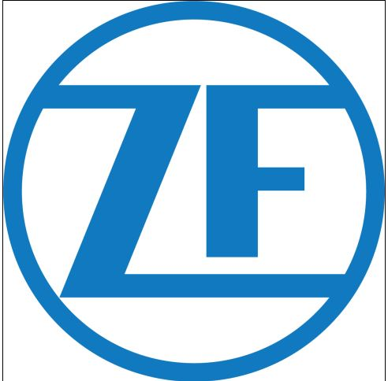

**Upcoming Meeting Dates:**

February 21, 2018

April 25, 2018

* **Welcome & Approval of Minutes**
  + Sandra Simon-Grindy, Chair, Lanier Islands
* **State WBL Conference Update**
  + Rhonda Samples, Director of CTAE, Hall County
* **State Website Reveal**
  + Deana Harper, WBL Coordinator, NHHS
* **Hall County WBL Website**
  + Suzanne Haynes, WBL Coordinator, WHHS
* **Upcoming Action Items**
  + Sandra Simon-Grindy, Chair, Lanier Islands
* **Website Quotes/Logos**
  + Holli Howard, WBL Coordinator, CHS
* **New Business**
  + Sandra Simon-Grindy, Chair, Lanier Islands

### November 8, 2017

### 11:30 a.m. - 12:30 p.m.

### Hall County Board of Education

Gainesville, GA 30501