

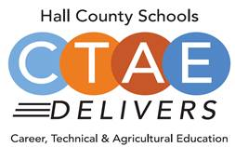

**Advisory Council**

Greg Vitek, Chair  
 Work Force Strategies Group

Tabitha Weaver, Secretary  
 Kipper Tool

**Hall County Career Specialists**

Karen Filchak, Cherokee Bluff

Holli Howard, Chestatee High

Staci Crain, East Hall High

Christy Carter, Flowery Branch High

Cree Aiken, Johnson High

Kim Guy, Lanier College and Career

Kristi Sims, North Hall High

KayLynn Samples, North Hall High

Suzanne Haynes, West Hall High

**Hall County CTAE Staff**

Rhonda Samples  
 CTAE Executive Director

Heather Barrett  
 CTAE Assistant Director

Deana Harper  
 WBL/YAP Coordinator

[www.hallcowbl.org](http://www.hallcowbl.org) PW: wblworks

## AGENDA

* **Welcome, Approval of Minutes**
  + Greg Vitek, Chair, Work Force Strategies Group
  + Website: [www.hallcowbl.org](http://www.hallcowbl.org)
  + Password: wblworks
* **WBL Student Spotlight**
  + Vanessa Chavez, Specialty Clinics Ortho, CHS
* **CTAE District & COVID-19 Updates**
  + Rhonda Samples, CTAE Executive Director
* **Perkins Plan Follow-Up** 
  + Heather Barrett, CTAE Assistant Director
* **A-Z Career Ready Update**
  + Greg Vitek, Chair, Work Force Strategies Group
* **Industry Case Study Work Session**
  + Greg Vitek, Chair, Work Force Strategies Group
* **Focus Group/Top Interview Questions**
  + Greg Vitek, Chair, Work Force Strategies Group
* **New Business**
  + Employee Appreciation Date:
    - May 28, 2021

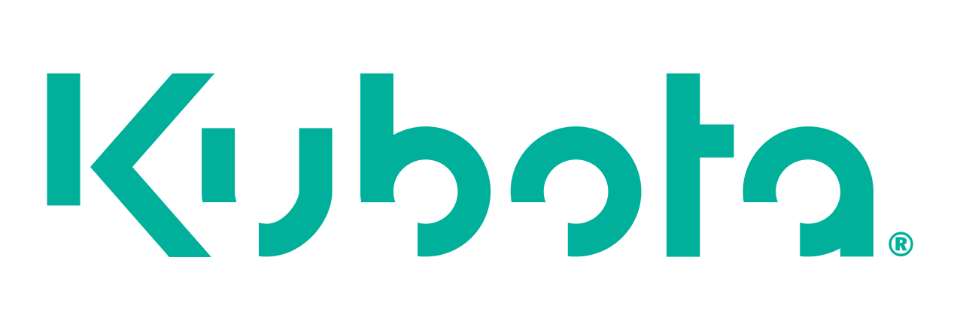

**Thank you to our lunch sponsor!**

### March 18, 2021

### 11:30 a.m. - 12:30 p.m.

### Lanier College and Career Academy

2723 Tumbling Creek Rd.  
Gainesville, GA 30504

# CTAE/WORK-BASED LEARNING ADVISORY COMMITTEE