



## AGENDA

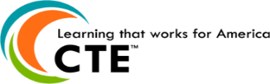

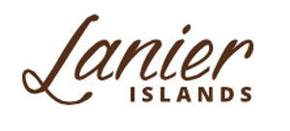

*Thank you Sandra Grindy and Lanier Islands for sponsoring lunch today!*

* **Welcome & Approval of Minutes**
  + Robert Riedinger, Chair, Hall County Tax Commissioner
* **WBL Student Spotlight**
  + Skylar Kitchen, FBHS Teaching Intern, Cherokee Bluff Middle
* **Old Business**
  + Robert Riedinger, Chair, Hall County Tax Commissioner
* **Hall County WBL Updates**
  + Holli Howard, Coordinator, Chestatee High School
* **Program Action Items**
  + Robert Riedinger, Chair, Hall County Tax Commissioner
* **WBL Promotional Elevator Speech** 
  + Robert Riedinger, Chair, Hall County Tax Commissioner
* **New Business**
  + Meeting dates:
    - April 10
    - May 30 (Appreciation Reception)

# WBL/YAP Advisory Committee

**Hall County Career Specialist**

Karen Filchak, Cherokee Bluff

Holli Howard, Chestatee High

Staci Crain, East Hall High

Christy Carter, Flowery Branch High

Karen Filchak, Flowery Branch High

Cree Aiken, Johnson High

Kim Guy, Lanier College and Career

Deana Harper, North Hall High

Kristi Sims, North Hall High

Suzanne Haynes, West Hall High

### January 23, 2019

### 11:30 a.m. - 12:30 p.m.

### Hall County Board of Education

Gainesville, GA 30501