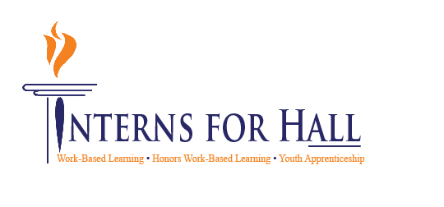

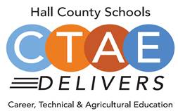

* **Welcome, Introductions & Approval of Minutes**
  + Greg Vitek, Chair, Work Force Strategies Group
* **Member Information Handouts**
  + Holli Howard, Chestatee WBL Coordinator
* **WBL Student Spotlight**
  + Wyatt Wallace, Kubota, LCCA WBL Student
* **CTAE District & COVID-19 Updates**
  + Rhonda Samples, CTAE Executive Director
* **Perkins Plan Follow-Up** 
  + Heather Barrett, CTAE Assistant Director
* **WBL Awards Update**
  + Deana Harper, Hall County WBL Coordinator
* **Hall County WBL Now Hiring Resource**
  + Christy Carter, Flowery Branch, WBL Coordinator
* **Work Session-*A-Z Skills List***
  + Karen Filchak, Cherokee Bluff WBL Coordinator
* **Employability Skills Project**
  + Greg Vitek, Chair, Work Force Strategies Group
* **New Business**
  + Upcoming Meeting dates:
    - January 11, 2021
    - March 18, 2021
    - May 28, 2021

**Advisory Council**

Greg Vitek, Chair  
 Work Force Strategies Group

Tabitha Weaver, Secretary  
 Kipper Tool

**Hall County Career Specialists**

Karen Filchak, Cherokee Bluff

Holli Howard, Chestatee High

Staci Crain, East Hall High

Christy Carter, Flowery Branch High

Cree Aiken, Johnson High

Kim Guy, Lanier College and Career

Kristi Sims, North Hall High

KayLynn Samples, North Hall High

Suzanne Haynes, West Hall High

**Hall County CTAE Staff**

Rhonda Samples  
 CTAE Executive Director

Heather Barrett  
 CTAE Assistant Director

Deana Harper  
 WBL/YAP Coordinator

### October 20, 2020

### 11:30 a.m. - 12:30 p.m.

### Lanier College and Career Academy

2723 Tumbling Creek Rd.  
Gainesville, GA 30504

## AGENDA

# CTAE/WBL/YAP Advisory Committee