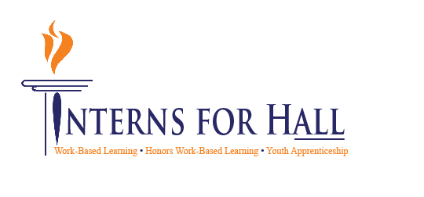00



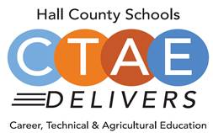

* **Welcome, Approval of Minutes**
  + Greg Vitek, Chair, Work Force Strategies Group
  + Spring Hiring Fair update
* **WBL Student Spotlight**
  + Lawson Smith, North Hall School, Jacobs Media
* **New Members Information Forms** 
  + Carin Booth, CBHS
* **Manufacturing Month (October) Tours**
  + Carin Booth, CBHS
* **CTAE District Updates**
  + Rhonda Samples, CTAE Executive Director
* **Comprehensive Local Needs Assessment Update** 
  + Heather Barrett, CTAE Assistant Director
* **Work Session: Brainstorm Young Professionals Day**
  + Greg Vitek, Chair, Work Force Strategies Group
* **New Business**
  + Next Meeting:
    - November Advisory Committee Newsletter
    - January 11, 2023

 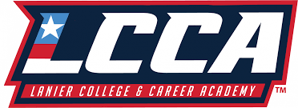

**Thank you to our lunch sponsor!**

**Advisory Council**

Greg Vitek, Chair  
 Work Force Strategies Group

Tabitha Weaver, Secretary  
 Gainesville Mechanical

**Workforce Development Team**

Carin Booth, Cherokee Bluff

Holli Howard, Chestatee High

Kami Kovach, East Hall High

Christy Carter, Flowery Branch High

Suzanne Haynes, Hall County Schools

Cree Aiken, Johnson High

Kim Guy, Lanier College and Career

Kristi Sims, North Hall High

KayLynn Samples, North Hall High

Cammie Carter, West Hall High

**Hall County CTAE Staff**

Rhonda Samples  
 CTAE Executive Director

Heather Barrett  
 CTAE Assistant Director

Deana Harper  
 WBL/YAP Coordinator

[www.hallcowbl.org](http://www.hallcowbl.org) PW: wblworks

## AGENDA

### September 14, 2022

### 11:30 a.m. - 12:30 p.m.

### Lanier College & Career Academy

2719 Tumbling Creek Rd.   
Gainesville, GA 30504

# CTAE / Work-Based Learning

# Advisory Committee