Understanding Payroll
Activity 2

Directions:
Follow the instructions at the end of this assignment for two activities and submit according to your WBL Coordinator’s instructions. Remember, you are receiving a grade for this assignment.

2. Payroll Taxes: Dependents/Allowances-
You have a say about the money that comes out
of your paycheck and goes to pay your income taxes!
It’s all in the forms you complete as a new employee.

Let’s start by looking at Federal and State Income Taxes…..

Our government collects income tax based on the amount of money you earn every calendar year, January – December. Think of the process like this:

- You worked during 2019 and by the end of the year, you had earned $22,100. | - Based on your $22,100 income, the federal government determined that you owe around $2,461 in federal income taxes for 2019.
- Based on your $22,100 income, the state government determined that you owe $1,326 in state income taxes for 2019. | - Would you prefer to pay these amounts in one lump sum or pay a small amount WITHHELD from each paycheck?  The withholding process helps you pay a little from each paycheck so that you won’t owe the entire amount at once when you file your tax return every year by April 15th!

Good news- YOU determine how much is withheld from each paycheck! It all depends on how much of your earnings you need to keep for living expenses and how much that you can afford to pay in for taxes

Go to next page

For example:
These two men have the same job, work the same number of hours, and earn the same pay. However, the amount they get to bring home is very different. (This could be women, too!)

Married couple with four children Single person, unmarried, no children

Consider this: Which man will require more money in his pocket to spend on groceries, medical needs, clothing, daycare, insurance, etc. With that in mind, which one needs to bring home as much of his earnings as possible to meet the needs of his household?

The government requires less tax from the married father’s pay because he has four children that DEPEND on him to meet their needs. The married man’s children are called his DEPENDENTS/ALLOWANCES. Spouses are not considered a dependent in ordinary circumstances. Because the single person has no dependents, the government requires more tax from his pay; thus he brings home less money than the married man with the family.

LOOK: You are single and get paid $1,339 every two weeks or ‘biweekly’.
How much should your employer withhold from your check for federal taxes? Since you are single and have no children, you only have one allowance (1), yourself.
How much will be withheld from your paycheck for federal income taxes?
Look at the partial federal withholding table below and notice the circled items:

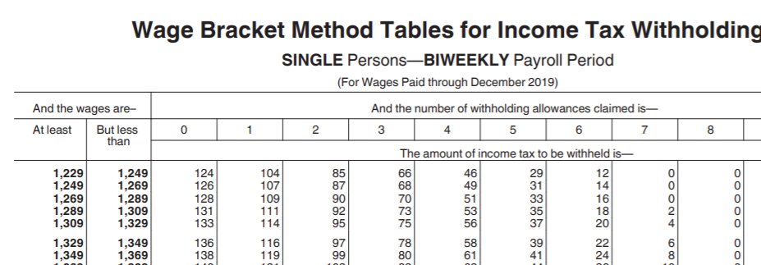

If you said, $116, you were correct!

Go to next page

LOOK: If you were married and earning $1,850 biweekly and had 4 allowances,
how much would be withheld from your paycheck for federal income taxes?
Look at the partial federal withholding table below and notice the circled items:

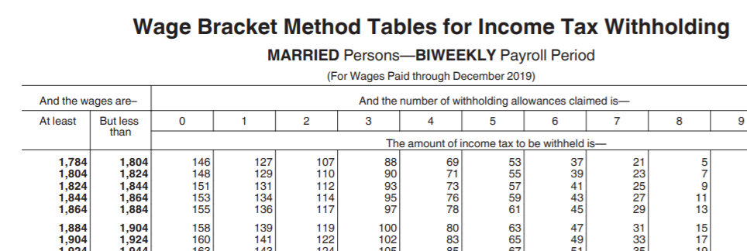

If you said, $76, you were correct!
So, how does your employer know how much to withhold from your pay?
When you go to work as a new employee for an organization, they are legally required to keep part of your pay and send it to the government for tax purposes. The only way an employer can withhold the correct amount is for you to provide them with correct information. You provide this information by filling out withholding forms. You will be required to complete withholding forms each time you start a new job.

To withhold the correct amount for your To withhold the correct amount for your
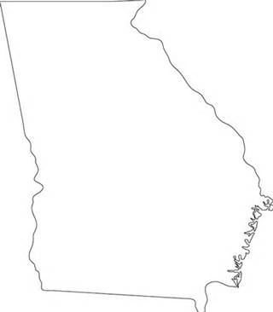
Georgia state income taxes, you will complete federal (USA) income taxes, you will complete Form G-4 Form W-4
Form W-4
Form G-4

Payroll Activity 2 Instructions:
Assume the part of a newly hired employee. You are required to fill out new-employee paperwork and income tax withholding forms are a few of many documents you must complete. In order for your employer to withhold the correct amount from your pay, you have to complete forms G-4 and W-4. Follow the instructions for accessing both Form G-4 and Form W-4 and use a false social security number.

Form G-4: Go to this webpage: https://dor.georgia.gov/form-g-4-employee-withholding
- Click to open the PDF for the Employees Withholding Allowance Certificate G-4
- ONLY fill in Lines 1a, 1b, 2a, 2b, 3. TAKE A PHOTO of the filled in lines and submit according to your school’s WBL Coordinator’s instructions. If you were actually completing this for a job, you would complete the entire form.
- Read over the remainder of page 1 so you see all of the actual required information.

Form W-4: Go to this webpage: https://www.irs.gov/pub/irs-pdf/fw4.pdf
- ONLY fill in all the lines in Step 1. TAKE A PHOTO of the completed Step 1 section and submit according to your school’s WBL Coordinator’s instructions. If you were actually completing this for a job, you would complete the entire form.
- Read over the remainder of page 1 so you see all of the actual required information.

