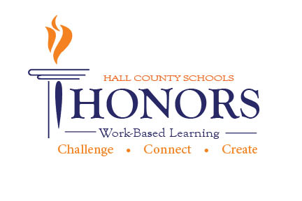

HALL COUNTY CAREER RELATED EDUCATION
HONORS WORK-BASED LEARNING PROGRAM
COURSE SYLLABUS

Admissions Policy
Junior or Senior; previous honors coursework; approval of WBL coordinator; have an identified career goal; at least 16 years of age; previously or currently enrolled in a connecting cluster related class; (reliable transportation, on track for graduation; minimum of two teacher recommendations; and completed the Work-Based Learning application process; enrolled in WBL for 1st and 2nd periods or 6th and 7th periods. Disciplinary actions, excessive absences and/or lack of clearly defined career goal may result in a student not being admitted into the WBL Honors program. Honors students are selected upon correlation of prior coursework, career goals and WBL placement.

Credit One unit of credit for each release period.

Instructor Work-Based Learning Coordinator

Course Description
The Work-Based Learning Honors Program involves businesses, schools and community organizations working together to provide high school juniors and seniors with an education rich in both rigorous academics and practical work-related experiences – teaching them the tasks, skills and responsibilities associated with today’s workplace. Today’s high-skilled job market demands that all high school graduates – whatever their career destinations – have advanced academic knowledge and work place skills. This program is designed for the student who has a clearly defined career goal. Students will have the opportunity to take advantage of state approved pathway offerings at their perspective school. The WBL honors program will culminate their internship experiences, research on industry trends and projects in a visual format by creating and maintaining an industry recognized e-portfolio. E-portfolios will provide hands-on learning opportunities and to help students successfully make the transition from high school to college and from college into the workplace.

Course Goals
- Inform students of the increasing complex world of work
- Participate in Georgia Business Ethics Student Training Program
- Participate in technology training and work/seminar sessions
- Assist students in developing appropriate attitudes about work
- Provide the opportunity for learning useful employability skills on real jobs under actual working conditions
- Help students to recognize how they can prepare for and advance in the perspective career
- Reinforce written and oral communication and applied knowledge in real-world settings
- Assist students in the development of good work habits, attitudes, appreciation and respect for work necessary for individual maturity and job competence
- Assist students in fulfilling responsibilities at the training location and classroom responsibilities in an efficient manner
- Demonstrate the capacity to think critically and solve complex problems
- Require prompt completion and maintenance of all electronic documents related to employment
- Require a higher level of cognition, critical analysis and application
- Participation in scholarly and creative processes
- Use of imagination, originality, creativity, innovation and critical initiation
- Personalized learning experiences
- Learn to express and defend ideas and accept constructive criticism
- Students will work together as a team to develop and implement a Service Learning Project

What is an e-Portfolio?
An e-Portfolio is a collection of a student’s work in electronic format. An e-Portfolio may contain all or some of the following:
- Supporting documentation formats (text, pictures, video, etc.)
- Evidence of education obtained and career pathway preparation
- Evidence of related class assignments, job shadows, field trips, internships or case studies
- Evidence of extracurricular activities.
- Evidence of service learning activities
- Career or industry related research papers and reports
- Evidence of industry recognized credentials or certifications received
- Related projects
- Evidence of post-secondary goals and objectives

The e-Portfolio brings together creativity, originality, reflection, as well as substantive evidence of learning throughout a student’s school year in a way unique to their overall educational experience.
Grading

Career Related Education Program grading criteria is as follows:
- Semester Average consists of the following categories:
  - Program Documentation (10%)
  - Required Hours/E-portfolio (40%)
    - e-portfolio requirements
      - About Me
      - Evidence of Soft Skill Development
      - Professional Documents
        - Resume (update for year 2)
        - Cover Letter (year 2)
        - 3 Letters of Recommendation (year 2)
        - Elevator Speech Video (year 2)
        - Work Philosophy (year 2)
    - Career Goals – short/long term goals – Individual Career Plan
    - Research Project – Trends in industry
    - Experience Highlights – Photo Journal/Gallery
    - Post-Secondary Goals and Activities
    - Service Learning Project
  - Monthly Assignments (30%)
  - Employer Evaluations (20%)
- Final Average will include the Exam/Portfolio (20%) and the Semester Average (80%).
- Due to the nature of the Work-Based Learning course requirements by the state (i.e., on the job time documentation and employer evaluations), Hall County School’s final exam exemption policy does not apply to all parts of the Work-Based Learning final exam. The final exam exemption policy applies only to the work-ethic activity portion of the Work-Based Learning final exam. The final exam exemption policy does not apply to any work-time verification documentation (time sheets or pay stubs) and Summative Employer Evaluation, with these items being required for completion as two parts of the three-part final exam. If a student meets Hall County School’s final exam exemption policy criteria, the activities portion of the final exam will be omitted in final exam grading calculations. The Work-Based Learning final exam consists of three parts with each part counting as one-third of the final exam grade.

To Parents

Progress reports are available every six weeks on Infinite Campus. Additional expectations/commitments/time are required for Honors WBL. If you have any questions, feel free to contact the instructor.

Career Related Education PROGRAM COURSE SYLLABUS cont.

Program Rules

- Complete all necessary documentation paperwork before reporting to your internship experience.
- Attend all orientation/training/meetings as required by your work based learning coordinator.
- Be regular in attendance at school and on the job. Excessive absences and/or tardies will affect your final grade and will require written documentation.
- Go to work only when attending class at school. The student must be counted present for school that day in order to go to the worksite.
- Obtain the coordinator's permission prior to terminating a job or internship experience.
- Remain under coordinator's supervision during class periods designed for work whenever unemployed.
- Report immediately to the coordinator any job termination/job problem.
- WBL students are required to personally sign out before leaving campus in the designated area. Discipline procedures will be administered in not followed.
- Do not entertain personal visitors while on the job or use the phone unless necessary for an emergency situation, and then will ask permission from my supervisor.
- Risk being dropped automatically from the program because of incompetence or negligence on the job and receive a grade of 50 for that grading period.
- Learn to ask questions at place of employment and during the related class or instruction when you do not understand certain instructions and procedures related to on-the-job training.
- Bring in check stubs and/or weekly wage reports to verify work hours and rate of pay. Internship student will need to complete hours documentation forms.
- Keep all forms, reports and assignments up-to-date and turned in on time or as directed by the coordinator.
- Strive to maintain passing grades in all school subjects never using the Career Related Education program as an excuse for obtaining special privileges or as an excuse for not getting work done or serving detentions for other teachers.
- Be evaluated during each grading period on my skills, knowledge, traits, attitudes, and attendance, at school and on the job.
- Notify employer by 8:30 a.m. if you are going to be absent from work. Schedule time off for special events related to school several days in advance.
- Provide own reliable transportation to and from work. Parents or guardians will assume the responsibility for a student’s safety and conduct from the time he/she leaves school until he/she reports to the job; likewise, from the time leaving the job until arriving home.
- Be attentive and cooperative in class and on the job, accepting any guidance and counseling cheerfully.
- Leave campus upon completion of the regular school day unless I have permission for official school business from a teacher. If caught on campus, discipline procedures may be administered.
- Learn and abide by the rules and regulations established by the employer.
- Attend the annual Career Related Education Appreciation function/GA BEST recognition ceremony if held in the spring.

I agree to continually comply with all regulations, policies, rules and procedures in order to maintain my enrollment in Honors Work-Based Learning.

___________________________________ _____________________
Student Signature Date

___________________________________ _____________________
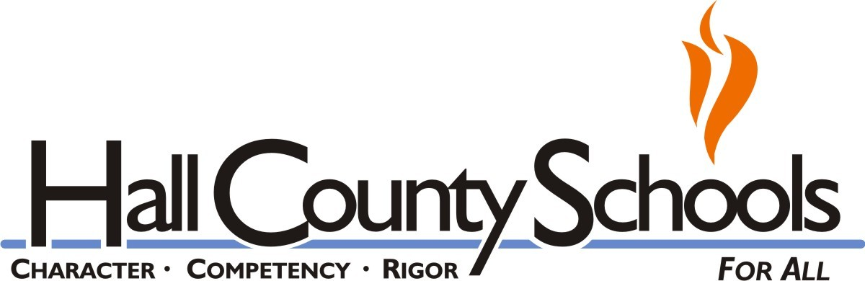
Parent Signature Date

Hall County Schools do not discriminate on the basis of sex, religion, creed, age, national origin, marital status or handicapping conditions in its educational programs or employment.

