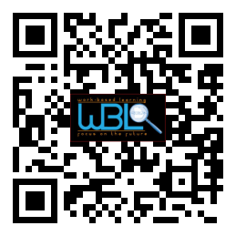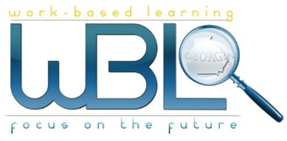0

### October 28, 2014

### 11:30 a.m. - 12:30 p.m.

### Hall County Schools

*711 Green Street*

*Gainesville, GA 30501*

* **Meeting called to order:** Robert called to order the first meeting of the 2018-2019 WBL/YAP Advisory Committee at 11:40 a.m. on October 3, 2018.
* **Members in attendance:**

|  |  |  |  |
| --- | --- | --- | --- |
|  | |  |  |
| |  |  |  |  | | --- | --- | --- | --- | | Al Trembley | Phil Bonelli | Emily Coffey | Shelley Davis | | Robert Riedinger | Lisa Geyer | Regina Summerour | Karen Filchak | | Scott Santimer | Matt Stowers | Laura Major | Suzanne Haynes | | Alex George | Latrice Richardson | Staci Crain | Kristi Sims | | Dana Miller | Cree Aiken | Christy Carter | Holli Howard | | Dallas Sage | Curt Sloyer | Andi Harmon | Amy Brock | | David Lynn | Sherree Moss | Janice Thao | Beth Ann Hamilton | | Greg Vitek | Kim Guy |  |  | | |  |  |
|  |  | |  |  |  |

* **Invitees not in attendance:**

|  |  |  |  |
| --- | --- | --- | --- |
| Levi Nix | Eddie Brock | John Tankersley | Lorrie Caruana |
| Latrice Richardson | Dennis Stockton | Zachary Brackett | Allison Smith |
| Kevin Hankinson | Mike Holman | Mark Miller | Emily Hayes |
| Greg Worley | Beth Garrish | Greg Whitmire | Sandra Stringer |
| Sandra Simon Grindy | Vaughan Smith | Rose Proctor | Shannon George |

**Welcome and introduction:** Upon arrival, each member and guest were welcomed and provided with a name tag. Everyone was invited to pick up their lunch provided by Emily Coffey with Chick-fil-A. Holli Howard introduced Robert Riedinger as the new chairperson for the WBL/YP Committee. Robert opened the meeting.

* **Old business:**
  + Robert called the meeting to order and thanked everyone for attending.
  + Minutes from last meeting were approved.
  + Rhonda Samples gave a recap of the WBL/YAP Conference held in Savannah in September. Robert mentioned 27 states attended the conference; Hall County WBL Coordinators presented 8 sessions.

## Minutes10- 03-18

# WBL/YAP Advisory Committee

**Current business:**

* Hanna Culbertson, 2nd year Honors WBL student at Chestatee High School, presented her ePortfolio. She spoke about her internship experience and how she switched from an education internship last year to a healthcare placement this year. She emphasized the importance of the WBL program in discovering what you don’t want to do as well as discovering your passion.
* Beth Ann Hamilton presented information on the You Science Aptitude career assessment given to 9th graders. This aptitude assessment helps students understand their strengths and provides a detailed analysis of careers best suited for each student. It measures aptitude, interest, and connects to career opportunities based on student answers. You Science connects to schools by helping 9th graders focus early, informs students about college selection, and allows students an opportunity to complete a career pathway by their senior year. All materials are provided. You Science is releasing a middle school version in November.
* Shelley Davis presented a new WBL Manufacturing Video, featuring WBL students in manufacturing placements within our county. She emphasized the fact that approximately 30% of the workforce is currently in the manufacturing industry, yet only 40/700 WBL students in Hall County are in manufacturing placements. Greg Vitek mentioned the need to synchronize communication between businesses and the school system, as many people don’t recognize the career opportunities in this industry. Additionally, there are apprenticeships offered at many businesses, and Greg’s vision is that even more non-traditional WBL students will apply and fill these positions.

**New business**

* WBL informational brochures were provided to all members with the intent they be displayed at their place of business.
* Robert presented the goals list from the 2/21/18 meeting and asked members to review. (See attached).
* Action items were discussed; there are several upcoming events that WBL Coordinators need help with. Sign-up sheets were distributed. (See attached).
* Holli Howard mentioned the need for additional Industry Case Studies (some schools have already used current case studies). Writing of more case studies has been tabled until the next meeting.
* Rhonda Samples distributed WBL key fobs to members with the Hall County WBL website address.
* Any changes, questions, or concerns to the above items should be emailed to Holli Howard at [holli.howard@hallco.org](mailto:holli.howard@hallco.org).

**Adjournment:** Robert dismissed the meeting at 12:35 p.m.

Next meeting January 23, 2019