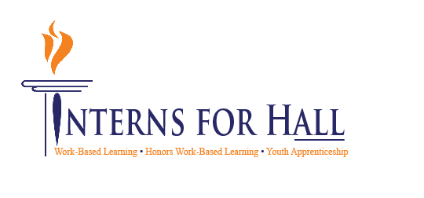
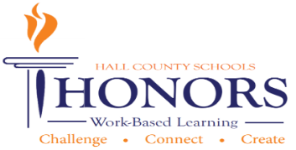
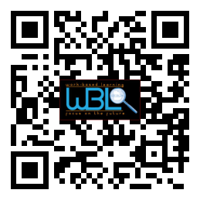

- Meeting called to order: Greg Vitek called to order the first meeting of the 2020-2021 WBL/YAP Advisory Committee at 11:34 a.m. on October 20, 2020

- Members in attendance:
Jill Ledford | Kelley Wilson | Dylan Duke | Rick Little
Robert Riedinger | Jeff Pruitt | Brandon Stephens | Ronny Hulsey
Alex George | Michelle Whitt | Mike Holman | Sandra Grindy
Melissa Nolan | Kaitlin Andrews | Shelley Logan | Nikki Chandler
Greg Vitek | Laura Major | Dennis Stockton | Kami Kovach
Amy Brock | Rhonda Samples | Heather Barrett | Deana Harper
Holli Howard | Kristi Simms | KayLynn Samples | Karen Filchak
Suzanne Haynes | Cree Aiken | Staci Crain | Christy Carter
Kim Guy | Lisa Geyer

- Invitees not in attendance:
Nathan Hamby | Al Trembley | Greg Worley | Tammy Patterson
Whitley Miller | Montyce Scott | Heather Roth | Shane McClellon
Andi Tippens | Emily Hayes | Zachary Brackett | Garrett Hibbs
Curt Sloyer | Olivia Etheridge | Beth Garrish | Tabitha Weaver
Vaughan Smith | Linda Haig | Janet Funk | Emily Herrin
Shannon George

October 28, 2014

11:30 a.m. - 12:30 p.m.

Hall County Schools
711 Green Street
Gainesville, GA 30501

Minutes 10-20-2020

WBL/YAP Advisory Committee
Welcome, Introductions & Approval of Minutes- Greg Vitek, Chair, Work Force Strategies Group
- Greg explains the after-hours school CTAE lab tours; he specifically mentioned the phlebotomy and welding labs; our students are being prepared, the preparations have been made for labs so that COVID is not an obstacle in our CTAE labs.
- New attendees were introduced: Judy Tilford (UGA Extension), Kaitlin Andrew (Work Source Georgia), Melissa Nolan (Lincoln Electric), Ronny Hulsey (Smith and Hulsey Law Firm), Rick Little (GA Mountain YMCA), Dylan Duke (Keller Williams Real Estate), Carli Jones (Jaemor Farms), Karin Booth (UGA Extension), Kelley Wilson (Island Entertainment), Brandon Stephens-(Kubota IT Systems Manager).
Member Information Handouts- Holli Howard, Chestatee WBL Coordinator
- Attendees are asked to complete the information page in their packet so that we can know the areas that they can assist our programs, i.e., guest speakers, field trips.
WBL Student Spotlight- Wyatt Wallace, Kubota, LCCA WBL Student

- WBL student highlight: Wyatt Wallace of LCCA’s Agri-Mechanic Program (second year); Kim Guy showed a video of student and his supervisor at Kubota (second year at K).

- Greg Vitek shared that the first standard in all CTAE courses is to cover soft skills

CTAE District & COVID-19 Updates- Rhonda Samples, CTAE Executive Director

- Rhonda Samples shared a presentation to update attendees of our district’s CTAE Programs’ participation numbers. This year:

  - 120 CTAE teachers this year in our district (14 new and 5 of those are from industry)
  - New programs: Auto CHS, Manufacturing WHHS (gave open invite to come to open house at WHHS)
  - Industry Certification: Auto EHHS, Culinary LCCA
  - 52 pathways from 15 career clusters
  - Lab renovations Construction CHS, AVFT WHHS
  - HCSD Agri-Business Center
  - FY20: Stats of CTAE participation 74.09% have at least one CTAE class with top choices are Healthcare Science, Arts areas of AVTF and Communications
  - FY19: 52.45% are pathway completers
  - FY18: 49.95% are pathway completers
  - FY21: Juniors and Seniors enrolled in CTAE course 3,759; 651 WBL students
  - FY20: 604 WBL students
  - District Initiative is Literacy (reading, writing, listening, speaking, thinking)

- Rhonda Samples shared District COVID update: Our school district’s website updates our positive-case numbers on a daily basis. We have a combined 30,000-plus people in our school system. As of 10/19/20, we have 15 positive cases. Our district has great awareness of safety measures with masks, cleaning/sanitizing, and distancing.
  - School Ambassador is a new paid job position for WBL students. The goal is to have our students employed with HCSD (paid) to work at schools helping take care of tasks that are new due to the COVID safety measures- this keeps these tasks from falling back onto the teachers.
  - LCCA businesses are up and running while maintaining the safety measures for COVID.
  - CTAE school labs have taken extra precautions so that students continue hands-on learning while maintaining safety measures (i.e., gloves).
  - WBL coordinators are aware of precautions for our students and we know that safety is best when everyone works together: community, Dept. of Health, nurses, schools

- Rhonda shared the current year’s Hall County Career Guide in everyone’s packet. It shows each career cluster and which schools offer the cluster(s).
- Greg Vitek: Asked the question- what does it take to get more WBL students from Jr/Sr classes? Rhonda responded that students have many options, including tuition free college, but that 25% would be a reasonable goal
Perkins Plan Follow-Up-Heather Barrett, CTAE Assistant Director

- Heather Barrett presents info on the CLNA/Perkins Plan
  - The CLNA and the Perkins Plan were both approved by GA DOE
  - The current Perkins Plan has 2 overarching needs:
    - There is a need to address industry demands and ensure alignment of the labor market needs in all of the career pathway offerings in Hall County Schools.
    - There is a need to meet the diverse challenges of all learners by providing innovative, creative and leadership opportunities for students enrolled in all of the career pathway offerings in Hall County Schools.
  - Every CTAE pathway in Hall County is aligned to industry demands
  - Hall County is providing every CTAE pathway CTSO opportunities virtually and opportunities through WBL. Virtual competitions are occurring for CTSO students.

WBL Awards Update- Deana Harper, Hall County WBL Coordinator

- Deana Harper: Recognizes Kristi Sims and KayLynn Samples for earning Digital Badge Awards, Holli Howard for winning NE GA Region WBL Coordinator of the Year and overall state winner; Kim Guy won the Career Guidance from TIGA and won overall state winner.
Hall County WBL Now Hiring Resource- Christy Carter, Flowery Branch, WBL Coordinator
- Christy Carter: Technology tool: Padlet- showed our website and our help wanted tab. Encouraged committee members to send job openings to Coordinators
Work Session- A-Z Skills List- Karen Filchak, Cherokee Bluff, WBL Coordinator

- Work Session:

  - Karen Filchak: A to Z Career Ready Terms, shared instructions to read and edit list and leave it on the table after meeting is over

Employability Skills Project- Greg Vitek, Chair, Work Force Strategies Group

  - Greg Vitek: Traits we want young people to bring to the work place; Name one to two key traits to bring to work place- keeping distance talk to other attendees and coordinators

- Greg Vitek: New Project for Worksource Georgia, 13 counties, wants to work with school systems through their AVTF programs to produce videos focused on employability skills – hence we take from A to Z list. Our goal is for the videos to become a teaching tool for the school systems. The next step for the development of these videos is a webinar meeting with all AVTF programs to develop a theme and standards for the videos. We will keep you updated on this as we go.
New Business

- Greg Vitek: Next meeting is on 01/11/2021, no new or old business was mentioned, the culinary program was credited with our delicious lunch.

- Rhonda Samples welcomed people to add to our meeting agendas if they have something to share or email her. Our committee’s participation doesn’t end here – we want ongoing guidance from industry.

- Greg Vitek adjourned at 12:29

