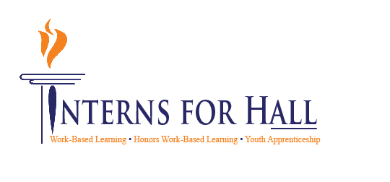
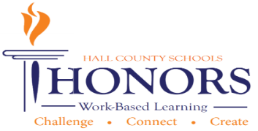
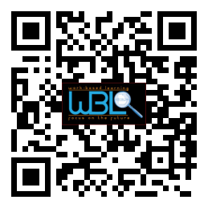

October 28, 2014

11:30 a.m. - 12:30 p.m.

Hall County Schools
711 Green Street
Gainesville, GA 30501

- Meeting called to order: Greg Vitek called to order the second meeting of the 2021-2022 CTAE/WBL/YAP Advisory Committee at 11:34 a.m. on January 19, 2022.

- Members in attendance:
Shane McClellon | Marissa Maynor | Richard Steele | Nathan Hamby
Nikki Chandler | Beth Purdy | Juergen Moller | Ashley Steinmetz
Brad Burdette | Mike Holman | Tabitha Weaver | Greg Vitek
Ashley Davis | Rhonda Samples | Kim Guy | Kristi Sims
Suzanne Haynes | Holli Howard | Jeff Pruett | Kate Everett
Chad Ledford | Matt Turner | Taylor Groves | Ebony Tucker
Robert Riedinger | Austin Anderson | Shannon George | Rick Little
Michelle Whitt | Shelley Logan | Deana Harper | Christy Carter
Carin Booth | Cree Aiken | KayLynn Samples | Heather Barrett

- Invitees not in attendance:
John Pinkerton | Judy Tilford | Emily Herrin
Linda Haig | Sandra Stringer | Al Trembley
Andi Tippens | Melissa Nolan | Zachary Brackett
Carli Jones | Becky Guyton | Vaughan Smith

Minutes 01-19-2022

CTAE/WBL/YAP Advisory Committee
Welcome, Introductions & Approval of Minutes- Greg Vitek, Chair, Work Force Strategies Group
- Greg welcomed members and thanked members for being in attendance. Introduced Holli Howard to present her student as a success story.
WBL Student Spotlight- Kate Everett, Rahab’s Rope, Chestatee High WBL Student
- WBL student highlight: Honors WBL Student, Kate Everett, discussed her Graphic Design Career pathway and how she is using that now at her internship with non-profit organization, Rahab’s Rope.

Member Information Electronic Form- Carin Booth, Cherokee Bluff WBL Coordinator
- Attendees are asked to complete the information page via Google Drive in order to create an electronic version so WBL and CTAE programs can utilize advisory members in their programs. Members were asked to complete a hard copy if they hadn’t already
Hall County Tech Fair
- Cree Aiken discussed the upcoming Hall County Tech Fair dates/times and asked for judge volunteers.

Action Item Update-Career Pathway Posters
- Holli Howard gave an update on the previous Action Item and thanked advisory for their input for the career pathway posters. Holli said the information was still being used to create posters and she will share when they are complete.
CTAE District & COVID-19 Updates- Rhonda Samples, CTAE Executive Director
- Rhonda Samples shared updates in the CTAE program:

  - Adding seven new pathways for CTAE: listed on sheet in folder provided
    - FY 20-40 Adding WBL
    - FY 21-52 Resources
    - FY 22-53 Personal Finance
    - FY23-60 Personal Finance and Economics, gov and social studies
  - Graduation Rate for CTA PW Completers 96.71% of GA, for Hall County 97.64%
  - 14 % higher than state rate
  - DOE State Rule is 15 years of age to be in WBL which will match the DOL rule
  - Economic Development Partnership Cert process-Hall County Hosting luncheon on 3/4/22 at LCCA. All Advisory will be invited and DOE will attend to verify all Hall Co does with community and partnerships to receive certification
  - CTAE Month-February- all schools will particiapte

Perkins Plan Follow-Up-Heather Barrett, CTAE Assistant Director
- Heather Barrett updated info on the CLNA/Perkins Plan
  - Need suggestions on labor alignment
  - List of 7 New CTAE Pathways
  - Full list of 60 pathways includes 7 new ones
  - Seeking feedback on labor alignment for Perkins Plan
  - Questionnaire –Fill out
    - Logistics? Not current pathway but they are working on educating students about what IS logistics. Not just freight aspect.
Work Session- Career Cluster Posters- Greg Vitek, Chair, Work Force Strategies Group
- Work Session:
  - Mentors are significant influences. What makes a mentor effective? Breakout sessions to discuss elements of eff. Mentoring best practices for mentoring.
  - Results
Qualities | Best Practices
Experienced | Plan/Road map for mentee
Good listener | Regular 1/1 coaching sessions
Communicator (mentee and WBL Coordinator) | Evaluation process
Heart of a teacher | Training them to work for you one day
Flexible | Career awareness
Know your audience | Hold them accountable for goals/tasks
Compassionate | Helps build confidence
Constructive coaching | Provide broad spectrum of opportunities
Patience | Weekly check-ins
Offers Accountability | Attendance accountability
Relatable | Checking in on school grades
Collaborates to set goals | Recognition/Networking to others
Understanding of skill set | Community Event Participation
Availability (time/coaching) | Team Engagement
Buy-in from organization | Provides Position Description/Org Chart
Team Mentality | Allows mentee to present project
    - Ideas: Mentor Class/becoming a mentor
    - Leadership Hall Co. Class becoming mentor?
New Business
- Greg Vitek: Next meeting is on 03/09/2022, no new or old business was mentioned, Kubota was credited for the lunch
- Greg Vitek adjourned at 12:34

