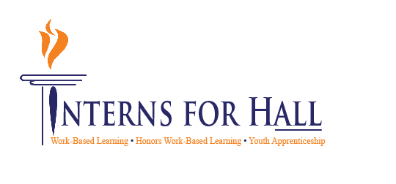00



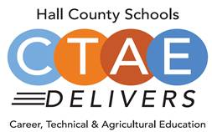

* **Welcome, Approval of Minutes**
  + Greg Vitek, Chair, Work Force Strategies Group
  + Website: [www.hallcowbl.org](http://www.hallcowbl.org)
  + Password: wblworks
* **WBL Student Spotlight**
  + Kate Everett, Chestatee, Rahab’s Rope
* **Member Information Forms**
  + Carin Booth, Cherokee Bluff
* **Hall County Tech Fair**
  + Cree Aiken, Johnson
* **Action Item Update-Career Pathway Posters**
  + Holli Howard, CHS
* **CTAE District & COVID-19 Updates**
  + Rhonda Samples, CTAE Executive Director
* **Comprehensive Local Needs Assessment Follow-Up** 
  + Heather Barrett, CTAE Assistant Director
* **Work Session**
  + Greg Vitek, Chair, Work Force Strategies Group
    - Business Partner Handbook Focus Group
* **Upcoming Dates:** 
  + Next Meeting:
    - March 9, 2022 (Honors WBL Presentations)

**Thank you to our lunch sponsor!**



**Advisory Council**

Greg Vitek, Chair  
 Work Force Strategies Group

Tabitha Weaver, Secretary  
 Gainesville Mechanic

**Hall County Career Specialists**

Carin Booth, Cherokee Bluff

Holli Howard, Chestatee High

Kami Kovach, East Hall High

Christy Carter, Flowery Branch High

Cree Aiken, Johnson High

Kim Guy, Lanier College and Career

Kristi Sims, North Hall High

KayLynn Samples, North Hall High

Suzanne Haynes, West Hall High

**Hall County CTAE Staff**

Rhonda Samples  
 CTAE Executive Director

Heather Barrett  
 CTAE Assistant Director

Deana Harper  
 WBL/YAP Coordinator

[www.hallcowbl.org](http://www.hallcowbl.org) PW: wblworks

## AGENDA

### January 19, 2022

### 11:30 a.m. - 12:30 p.m.

### Lanier College and Career Academy

2719 Tumbling Creek Rd.  
Gainesville, GA 30504

# CTAE / Work-Based Learning

# Advisory Committee