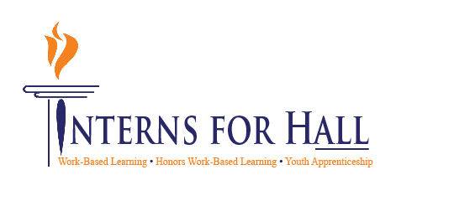



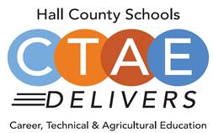

February 12, 2025

11:30 a.m. - 12:30 p.m.

Lanier College & Career Academy
2719 Tumbling Creek Rd.
Gainesville, GA 30504

CTAE / Work-Based Learning

Advisory Committee
(10:45 LCCA Program Tour for those that Signed Up)

- Welcome
  - Greg Vitek, Chair, Workforce Strategies Group
- Student Spotlight
  - Quinn Pierce, Orbital Energy Services, LCCA
  - Katherine Cardona Flores, Orbital Energy Services, LCCA
  - Nicholas Szilagyi, Orbital Energy Services
- CTAE/CLNA/WBL District Update
  - Deana Harper, CTAE Assistant Director
  - Suzanne Haynes, District YAP Coordinator
  - Kim Guy, WBL Coordinator, LCCA/VPOC
- Work Session
  - Youth Apprentice Programs
    - Greg Vitek, Chair, Workforce Strategies Group
Next Meeting
  - March 19,2025
    - Lanier College and Career Academy
    - Honors WBL E-Portfolio Gallery Walk

Thank you to Workforce Strategies Group for
sponsoring lunch today!
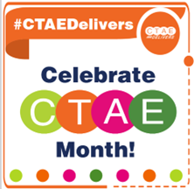
Advisory Council
Greg Vitek, Chair
Workforce Strategies Group

Workforce Development Team
Cree Aiken, JHS
Kennedy Barter, CBHS / FBHS
Carin Booth, CBHS
Cammie Carter, WHHS
Christy Carter, FBHS
KayLynn Godfrey, NHHS
Kim Guy, LCCA / VPOC
Suzanne Haynes, District YAP
Holli Howard, CHS
Kami Kovach, EHHS
Macey Parrish, CHS / EHHS
Betsy Pruitt, JHS/WHHS
Kristi Sims, NHHS

Rhonda Samples
CTAE Executive Director
Deana Harper
CTAE Assistant Director

www.hallcowbl.org PW: wblworks

AGENDA

