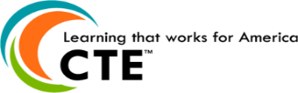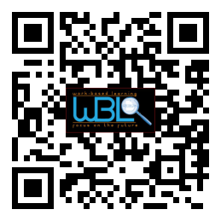

*We would like to Thank* ***Dustin Chambers of IMS Gear*** *for sponsoring our lunch for April’s WBL Advisory Meeting.*



You are cordially invited to attend the

Hall County Work-Based Learning

Employer & Business Partner Reception

Wednesday, May 31, 2017

11:30-12:30

The Oaks

Lunch will be served.

* **Welcome & Approval of Minutes**
  + Sandra Simon-Grindy, Chair, Lanier Islands
* **IMS GEAR-Lunch Sponsor**
  + Dustin Chambers, HR Generalist, IMS Gear
* **Student Intern Spotlight**
  + Shelia Sanchez-Braselton NGHS, Flowery Branch
* **Internship Placements for 2017-2018**
  + Christy Carter, WBL Coordinator, Flowery Branch
* **Program Review & Action Update**
  + Holli Howard, WBL Coordinator, Chestatee High
* **Employer Soft Skills Evaluation Review**
  + Sandra Simon Grindy, Chair, Lanier Islands
* **Sub-Committee Updates**
  + Sandra Simon-Grindy, Chair, Lanier Islands

**Hall County Career Specialist**

Holli Howard, Chestatee High

Staci Crain, East Hall High

Christy Carter, Flowery Branch High

Karen Filchak, Flowery Branch High

Cree Aiken, Johnson High

Deana Harper, North Hall High

Suzanne Haynes, West Hall High

## AGENDA

# WBL/YAP Advisory Committee

### September 6, 2017

### 11:30 a.m. - 12:30 p.m.

### Lanier Islands Legacy Lodge

*7000 Lanier Islands PKWY*

*Buford, GA 30518*