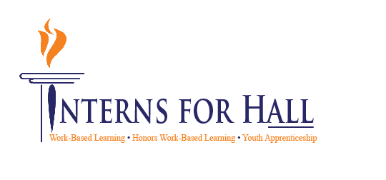
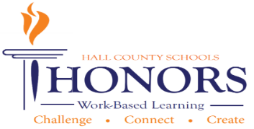
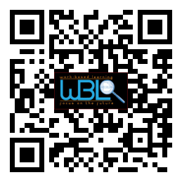

- Meeting called to order: Greg Vitek called to order the WBL/YAP Advisory Committee at 11:34 a.m. on March 18, 2021.

- Members in attendance:
Greg Vitek | Sandra Stringer | Shane McClellon | Dennis Stockton
Stefan Herr | Zach Brackett | Renee Cook | David Lynn
Shannon George | Sandra Simon Grindy | Al Trembley | Jeff Pruitt
Shelley Logan | Tabitha Weaver | Juergen Moller | Melissa Nolan
Tammy Patterson | Michelle Whitt | Shameka Harrison | Nikki Chandler
Montyce Scott | Rhonda Samples | Heather Barrett | Deana Harper
Holli Howard | Kristi Simms | KayLynn Samples | Karen Filchak
Suzanne Haynes | Cree Aiken | Staci Crain | Christy Carter
Kim Guy | Lisa Geyer | Rick Little | Chris Hulsey
Garrett Hibbs

- Invitees not in attendance:
Nathan Hamby | Whitley Miller | Andi Tippens | Carli Jones
Beth Garrish | Ashley Davis | Vaughan Smith | Alex George
Kaitlin Andrews | Mike Holman | John Pinkerton | Emily Hayes
Emily Herrin | Emily Hayes | Greg Worley | Linda Haig
Brandon Stephens | Janet Funk | Ronny Hulsey | Dylan Duke

October 28, 2014

11:30 a.m. - 12:30 p.m.

Hall County Schools
711 Green Street
Gainesville, GA 30501

Minutes 10-20-2020

CTAE/WBL/YAP Advisory Committee

WBL Student Spotlight: Vanessa from Chestatee HS
- Chestatee HS WBL (Virtual) Student - Vanessa; shared video with her experience
  - Tasks Vanessa does during her WBL shifts include: helping with vaccines and faxes; getting patients from the waiting room to their visit; takes vitals; cleans and turns rooms; and charting.
  - Favorite part of her experience: she enjoys bringing patients back and learning about their ailments
- Leah Gaither (WBL industry supervisor) says:
  - WBL promotes involvement in the community, develops the workforce, and encourages students; points out that personal motivation is a crucial skill – students need to be able to introduce themselves to customers and patients with authority.
  - Students need to learn to be ACTIVE employees!
  - Advice for other businesses: it’s beneficial to have people to pour into – showing students the right thing to do encourages best practices within your company.

CTAE Updates
- District is rolling out programs for 50+ career pathways
  - Ideal pathway will be completed with a capstone internship in the community
  - Website has been developed with great resources for students AND the community, and includes graduation requirements
  - Students do not have to complete a pathway to graduate
  - Trying to encourage kids to think about what they want to do when they graduate and how to get there
  - “Credentials of Value” from high school look great on a resume
- Covid-19 Update: 1% of students out for COVID but quarantine has been effective so far
- Criminal Justice is coming back to CBHS
- FCS lab at Davis Middle School is reopening
- Stacy & Karen are retiring at the end of the year
- Top Gun Training is something Hall Co. WBL provides; Kim Guy invited to become a part/become certified

Perkins Update
- Perkins gives money for the year
- Overarching need to fill out feedback
  - Form to be completed by stakeholders and left on table in the back before leaving at the end of meeting
  - Key factors: certifications needed for students, additional skills needed for students

Case Studies Work Session
- WBL team needs examples to provide for teachers to use during instruction
- These will be formatted and uploaded to WBL website

New Business
- Employer appreciation event date 5/28/2021
- Shelley Logan/Greg Vitek speak:
  - 2 major projects they’re working on: Skill boot camps and employability skills video
  - Skill Boot Camps were created to encourage employability skills after graduation (this is a pass/fail course). Students in this program must act out and show that they can handle skills, and as a result have the opportunity to learn skills and be interviewed by an employer at the end. Students are recommended for this program and are not required to pay. These boot camps last for two full days each.
  - 13 of 15 school systems in the region are creating videos about employability skills they’re learning at their WBL jobs. The goal is to share this video with students, and to create a regional library of WBL support, including videos, case studies, and more which feature regional employers.

Meeting adjourned at 12:30 p.m.

