
00

- Welcome
  - Suzanne Haynes, District YAP Coordinator
- CTAE/CLNA District Update
  - Rhonda Samples, CTAE Executive Director
  - Deana Harper, CTAE Assistant Director
- Work Session
    - Use of AI in Industry- Table discussion
- Next Meeting
  - January 28, 2026
  - Location: Hall County Schools Agribusiness Center/Farm
4439 Cleveland Hwy Gainesville, GA 30506

Thank You to Workforce Strategies Group for lunch sponsorship!

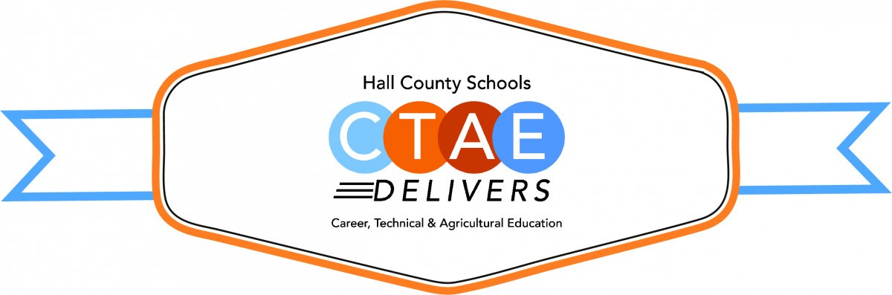

September 25, 2025

11:30 a.m. - 12:30 p.m.

Lanier College & Career Academy
2719 Tumbling Creek Rd.
Gainesville, GA 30504

AGENDA

CTAE & Work-Based Learning

Advisory Committee
Advisory Council
Greg Vitek, Chair
Workforce Strategies Group

Workforce Development Team
Cree Aiken, JHS
Kennedy Barter, CBHS / FBHS
Carin Booth, CBHS
Cammie Carter, WHHS
Christy Carter, FBHS
KayLynn Godfrey, NHHS
Kim Guy, LCCA / VPOC
Suzanne Haynes, District YAP
Holli Howard, CHS
Kami Kovach, EHHS
Molly Martin, JHS/WHHS
Macey Parrish, CHS / EHHS
Kristi Sims, NHHS
Carol Summer, LCCA

Rhonda Samples
CTAE Executive Director
Deana Harper
CTAE Assistant Director

www.hallcowbl.org
Password: wblworks

