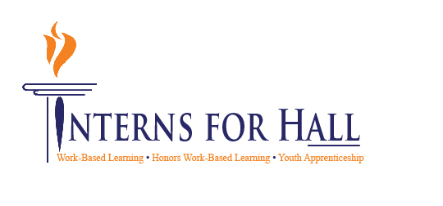
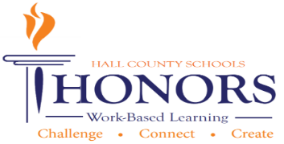

October 28, 2014

11:30 a.m. - 12:30 p.m.

Hall County Schools
711 Green Street
Gainesville, GA 30501

- Meeting called to order: Greg Vitek called to order the second meeting of the 2021-2022 CTAE/WBL/YAP Advisory Committee at 11:34 a.m. on March 9, 2022.

- Members in attendance:
Holli Howard | Carin Booth | Kim Guy | Shane McClellon
Michelle Whitt | Sandra Stringer | Zach Brackett | Juergen Moller
Nathan Hamby | Shameka Harrison | Melissa Nolan | Bard Burdette
Marissa Maynor | Joey Farah | Karen Ewing | Dennis Stockton
Robert Riedinger | Chad Ledford | Tabitha Weaver | Chris Hulsey
Rick Little | Ashley Davis | Lisa Geyer | KayLynn Samples
Kristi Simms | Suzanne Haynes | Christy Carter | Heather Barrett
Deana Harper | Kami Kovach | Cree Aiken | Greg Vitek

- Invitees not in attendance:
John Pinkerton | Judy Tilford | Emily Herrin
Linda Haig | Sandra Stringer | Al Trembley
Andi Tippens | Melissa Nolan | Beth Garrish
Carli Jones | Becky Guyton | Vaughan Smith
Shannon George | Alex George | Jenn Dunahoo
Al Trembley | Whitley Miller | John Jacobs
Sandra Simon-Grindy | Shelly Logan | Wendy Cunningham
Angela Horne | Melissa Nolan | Mike Robertson
Angela Solis | Ashley Steinmetz | Ronny Hulsey
Nikki Chandler | Mike Holman | Montyce Scott
Dylan Young | John Pinkerton

Minutes 3-09-2022

CTAE/WBL/YAP Advisory Committee
Welcome, Introductions & Approval of Minutes- Greg Vitek, Chair, Work Force Strategies Group
- Greg welcomed members and thanked members for being in attendance.
- Greg mentioned EDP Certification event/luncheon last week; received positive feedback from GADOE but will hear about a decision this shared.
- Shared 20-21 CTAE infographic and updated everyone about CTAE Programs
- 7th grade career fair is coming up at Lanier Tech and UNG
- Be Pro Be Proud Simulation bus is in Hall County March 14-18 visiting Johnson High School, Cherokee Bluff and Chestatee. Schools are on a rotation.
Hall County Hiring Fair
- Kim Guy gave information about the upcoming Hiring Fair for Hall County Schools on April 26 at LCCA. This targets Seniors. Business are invited to attend. Booth fee is $50. A flyer was handed out for view and for information on how to register. Schools will bus students to the event and the event will also take place after school hours so as many students/parents can attend. Email kim.guy@hallco.org if you want more information.

CTAE District Updates
- Deana Harper-EDP Event last Friday is critical to demonstrate partnership throughout the community. Wil find out later this spring and can announce in June if Hall County received this distinction.
- Introduction of CTAE Graduate Profile was handed out to each member. Goal is to grow students in 6 core areas identified by state of GA.
CLNA Follow-UP
- Heather Barrett-based on feedback 7 new pathways (now up to 60); comments from Advisory are always incorporated into Perkins Funding decisions through 3 overarching needs (handout was given) showing community involvement for official submittal, looking at adding logistics pathway based on feedback.

Work Session- Honors Work-Based Learning E-Portfolio Cap Stone Presentations
- Advisory members rotated through a gallery walk and visited 2-3 of the Honors WBL Students to offer them feedback and insight into their online portfolios.
- Rubrics were provided for members to make notes, these were given back to Coordinators to distribute to students for any final changes.
New Business
- Greg Vitek: Next meeting is on June 1, 2022 and it is the employer appreciate lunch and awards session
- Greg Vitek adjourned at 12:34

